Experiment No.: 3
1.Title: Creating Grading system using HTML, CSS, JS.
2. Software/Tools Required: VSC, HTML, CSS
3. Theory:
A grading system is a client-side web application built using HTML, CSS, and JavaScript to convert student marks into grades and SGPA. HTML defines the structure (form, table, inputs), CSS handles the visual styling, and JavaScript performs DOM manipulation, event handling, and conditional logic (if-else) to validate marks and calculate grade points. The final SGPA is computed using the credit-weighted average formula (Σ Grade Points × Credits / Σ Credits), all processed instantly in the browser without needing a server.
4. Output: 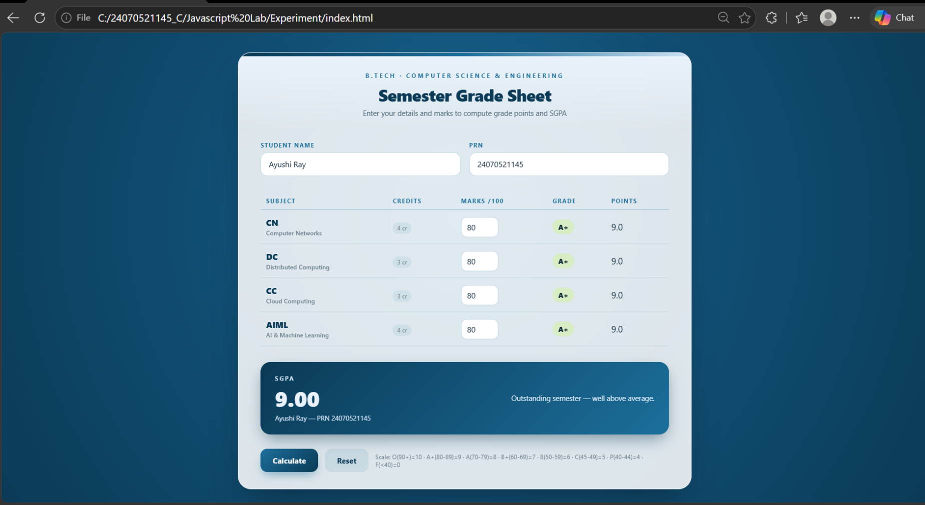
5. Result/Conclusion:
The webpage was successfully created using inline, internal, and external CSS. Different styling methods were implemented and compared, and the webpage displayed the required content with the desired formatting.

